
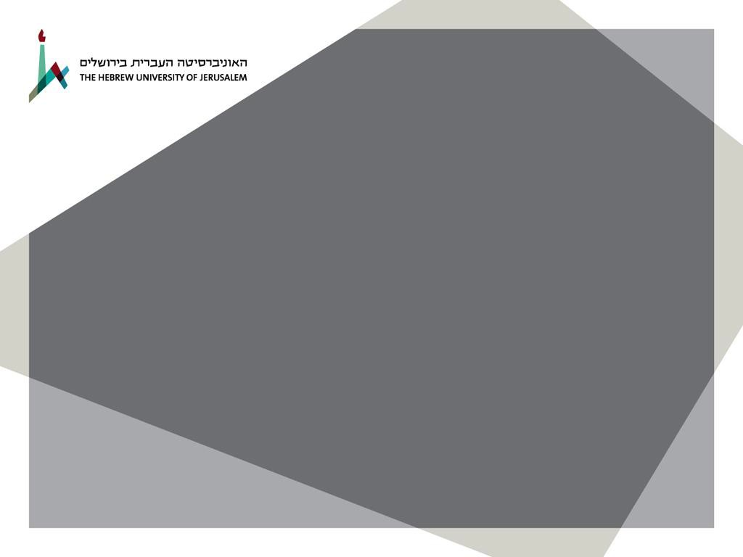
The Kaye Innovation Awards at The Hebrew University of Jerusalem
2023
The Authority for Research and Development is pleased to invite applications for the 2023 Kaye Innovation Awards.
All university faculty, staff and students are eligible to apply. The awards are in recognition of the development of a new product or system that has been marketed, brought revenue or savings to the Hebrew University, or that has significant commercial potential.

Submission Date: December 1st, 2022
To apply please click here
Submissions will only be accepted through the system.
For any technical problems, please contact the support team via e-mail: support@ekmd.huji.ac.il
For any questions, please contact Merav Atar by e-mail: merava@savion.huji.ac.il, or by phone: 026586626

The prizes will be awarded in a ceremony at the University’s Board of Governors Meeting to be held during the week of June 09-14, 2023. Awardees are required to attend the ceremony.
Please see submission guidelines and contact details below.

Submission Guidelines
The Kaye Innovation Awards
At The Hebrew University of Jerusalem
2023

The application should include:
A short CV of the candidate (including ID number). A colored photo of the candidate (in jpeg format). An abstract of the invention (up to 2 pages)
A detailed description of the invention’s revenues, savings for the University or
marketing potential
Two recommendations from University staff or from the relevant industry. (student candidates: one recommendation must be from the supervisor)
Articles written by the candidate (or figures, illustrations, etc.) A colored picture of the invention (in jpeg format).

Submission details:
Submission is via the Grant Submission System. http://scholarships.huji.ac.il

Contact person:
Merav Atar – Personal Assistant to the Vice President for R&D Tel: 02-6586626
E-mail: merava@savion.huji.ac.il

